

PRODUCT SPECIFCATION SHEET

**SERIES STANDARD FEATURES**

* 5/16” bolted thru rod construction
* DSB (13 specialty glasses optional or tempered)
* Commercial hardware
* 10 ball bearing steel rollers
* Inside slide lock
* 2” (3” available) bracket mounted track
* Torsion spring counterbalance
* Vinyl loop bottom seal
* 5 year limited warranty

**MODEL FEATURES**

* 2” Thick 6063-T6 aluminum extrusions
* .050 thick solid panel bottom section
* Tongue and Grove Rails
* Clear anodized finish standard  
  Optional finishes available
* Sizes up to 24’-2” wide & 16’ high
* Top & bottom Rails:  
  up to 20’2” wide = 4-1/8”, > = 7-1/8”
* End stiles:  
   up to 16’-2” wide = 4’-1/8”:
* Center stiles = 2”

*VENTANA COMMERCIAL SERIES*

**MODEL 550 ALUMINUM GARAGE DOORS**

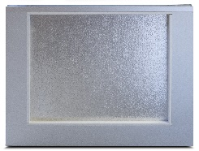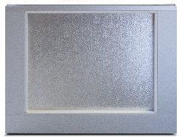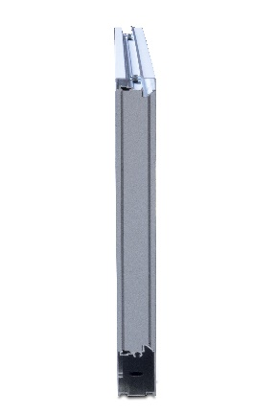

Powder-coat colors to match most Safe-Way models. Consult factory for custom colors.

Interior View

Exterior View

**AVAILABLE COLORS**

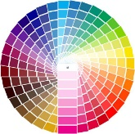

End View

Contact Your Local Dealer

Aluminum Anodized