

PRODUCT SPECIFCATION SHEET

**SERIES STANDARD FEATURES**

* 5/16” bolted thru rod construction
* DSB glass (13 specialty glasses optional or tempered)
* Commercial hardware
* 10 ball bearing steel rollers
* Inside slide lock
* 2” (3” available) bracket mounted track
* Torsion spring counterbalance
* Vinyl loop bottom seal
* 5 year limited warranty

**MODEL FEATURES**

* 2” Thick 6063-T6 aluminum extrusions
* .050 thick solid panel bottom section
* Tongue and Grove Rails
* Clear anodized finish standard  
  Optional finishes available
* Sizes up to 14’-2” wide & 14’ high
* 3” – Top, bottom & end stiles  
  1-7/8” center stiles

*VENTANA COMMERCIAL SERIES*

**MODEL 450 ALUMINUM GARAGE DOORS**

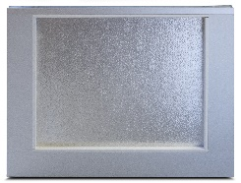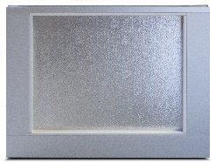

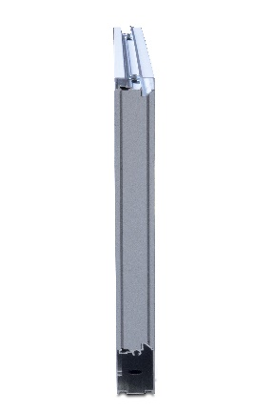

Exterior View

Interior View

**AVAILABLE COLORS**

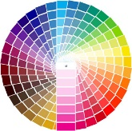

End View

Contact Your Local Dealer

Aluminum Anodized

Powder-coat colors to match most Safe-Way models. Consult factory for custom colors.